|  |  |  |
| --- | --- | --- |
| *Website connection time to* | | |
| Trials | **Post Reservation**  **(177 Bytes)** | **Get Reservation**  **(177 Bytes)** |
| 1 | 0.490 s | 0.411 s |
| 2 | 0.445 s | 0.420 s |
| 3 | 0.480 s | 0.451 s |
| 4 | 0.482 s | 0.423 s |
| 5 | 0.522 s | 0.416 s |
| Average | **0.4838 s** | **0.4242 s** |

|  |  |  |
| --- | --- | --- |
| *Application connection time to* | | |
| Trials | **Post Currently Looking**  **(52 Bytes)** | **Get Currently Looking**  **(52 Bytes)** |
| 1 | 0.383 s | 0.370 s |
| 2 | 0.370 s | 0.386 s |
| 3 | 0.313 s | 0.406 s |
| 4 | 0.410 s | 0.360 s |
| 5 | 0.436 s | 0.323 s |
| Average | **0.3824 s** | **0.3690 s** |

|  |  |  |
| --- | --- | --- |
| *Website connection time to* | | |
| Trials | **Post User**  **(113 Bytes)** | **Get User**  **(113 Bytes)** |
| 1 | 0.489 s | 0.418 s |
| 2 | 0.409 s | 0.373 s |
| 3 | 0.456 s | 0.436 s |
| 4 | 0.488 s | 0.369 s |
| 5 | 0.414 s | 0.428 s |
| Average | **0.4512 s** | **0.4048 s** |

|  |  |  |
| --- | --- | --- |
| *Application connection time to* | | |
| Trials | **Post Zone**  **(8606 Bytes)** | **Get All Zones**  **(8606 Bytes)** |
| 1 | 0.662 s | 0.722 s |
| 2 | 0.666 s | 0.716 |
| 3 | 0.656 s | 0.652 |
| 4 | 0.674 s | 0.712 |
| 5 | 0.712 s | 0.698 |
|  | 0.691 s | 0.654 |
| Average | **0. 8122 s** | **0.8303 s** |

|  |  |  |
| --- | --- | --- |
| *Website connection time to* | | |
| Trials | **Post spot**  **(49 Bytes)** | **Get All Spots**  **(49 Bytes)** |
| 1 | 0.362 s | 0.349 s |
| 2 | 0.287 s | 0.320 s |
| 3 | 0.342s | 0.324 s |
| 4 | 0.317s | 0.328 s |
| 5 | 0.345 s | 0.328 s |
| Average | **0.3306 s** | **0.3298 s** |

|  |  |  |
| --- | --- | --- |
| *Website Average Connection Time to* | | |
|  | **Post** | **Get** |
| Reservation (177 bytes) | 0.4838 s | 0.4242 s |
| Currently Looking (52 bytes) | 0.3824 s | 0.3690 s |
| User (113 bytes) | 0.4512 s | 0.4048 s |
| Zone (8606 bytes) | 0.8122 s | 0.8303 s |
| Spot (49 bytes) | 0.3306 s | 0.3298 s |

To test internet connection to and from the website and Firebase in several data sizes.

In average, the total time needed to read/write to and from Firebase is considered a small number, which is good for our system as it is in real time. However, the website needed more time to fetch data compared to the application. And significantly, we can find that time is directly proportional to the number of bytes. This delay in response time may refer to some factors, one of them is the server location. As it is known that server location has an impact on response time and page loading if it is far from the user location as in our case.

By using **www.iplocation.net**, we found that the server location based on its IP is located in United States. (see figure XX)

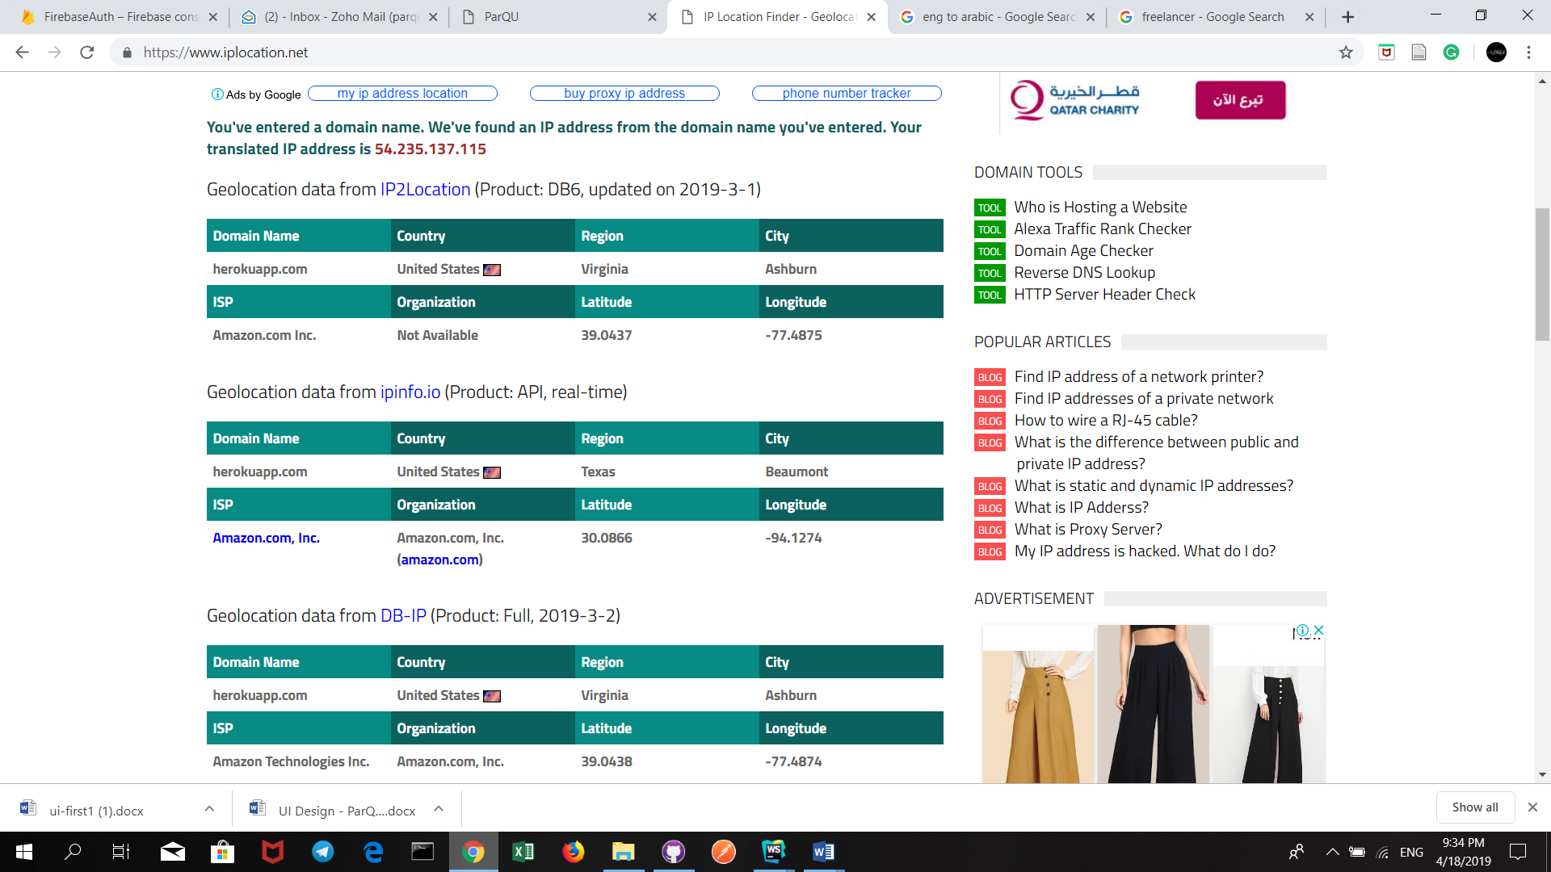



**Method of measuring time:**

Using Postman as a testing tool, by firstly creating new routes for reading/writing without displaying pages content and applying GET/POST requests using Postman as it automatically calculates the time it took for the response to arrive.

**Post reservation**



**Read reservation**



**Add current looking**



**Get current looking**

**A close up of a logo

Description generated with high confidence**

**Delete current looking**



**Post user:**



**Get user**



**Post zone**

A close up of a logo

Description generated with very high confidence

**Get All zones**



**Get spots**



**Post spot**

